ASSISTED PROJECT EMP ID : 2587303

NAME: R.HIMABINDU

1.You are given a project to implement @Test and other related annotations.

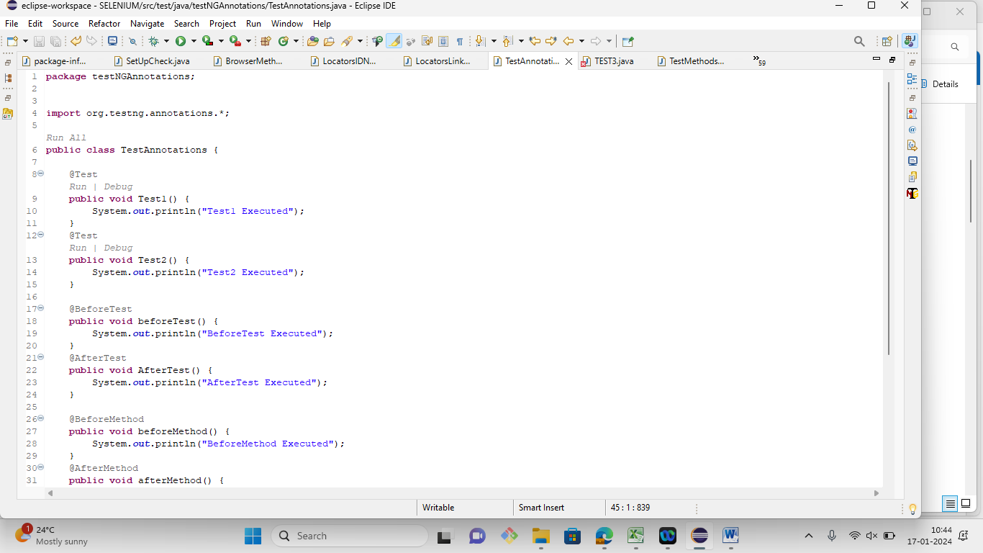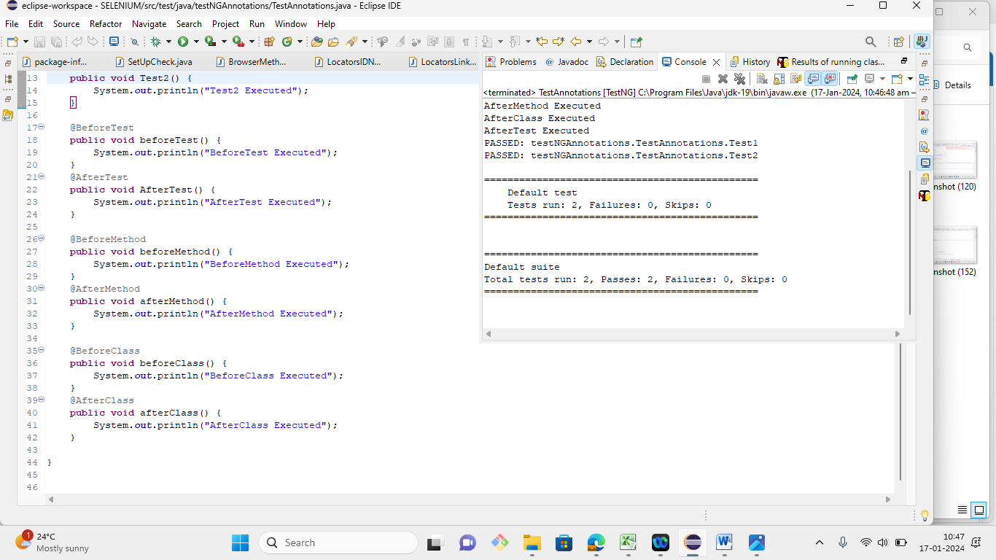

2. You are given a project to work with groups attribute of @Test and perform parallel execution.

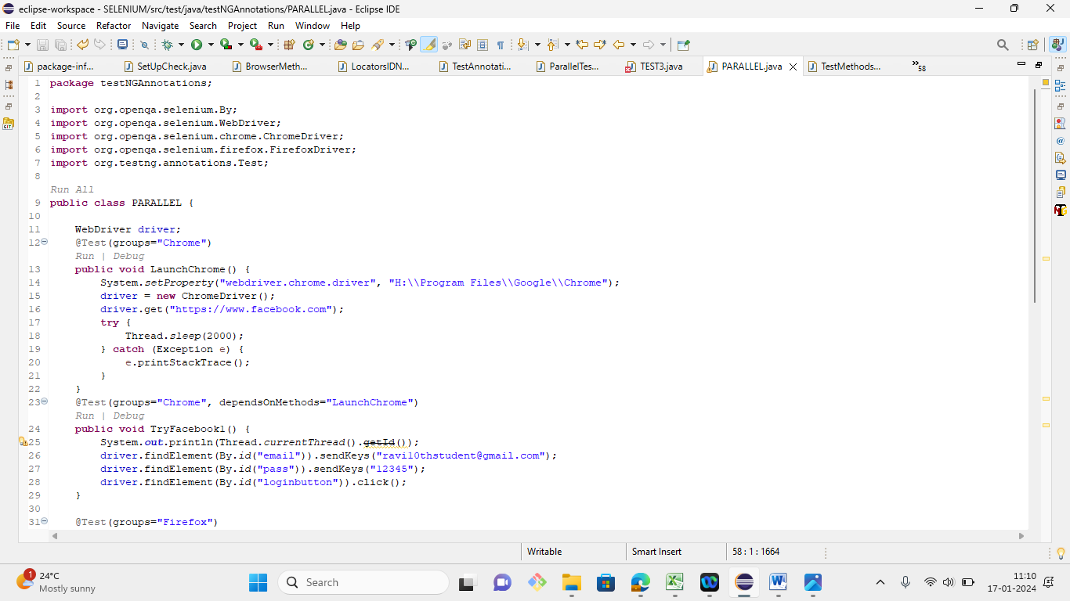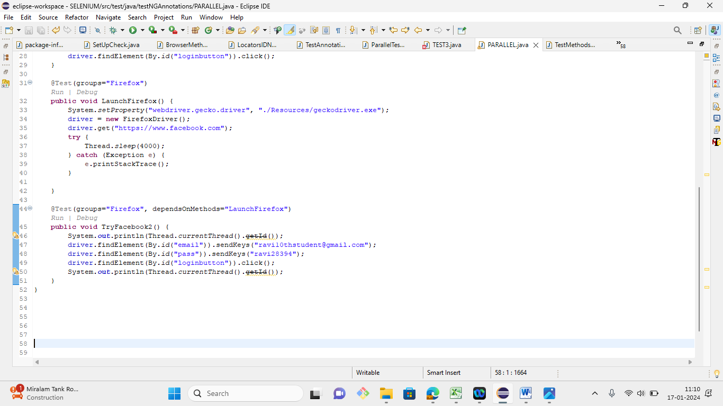

3. You are given a project to implement soft and hard assertions on your test cases.

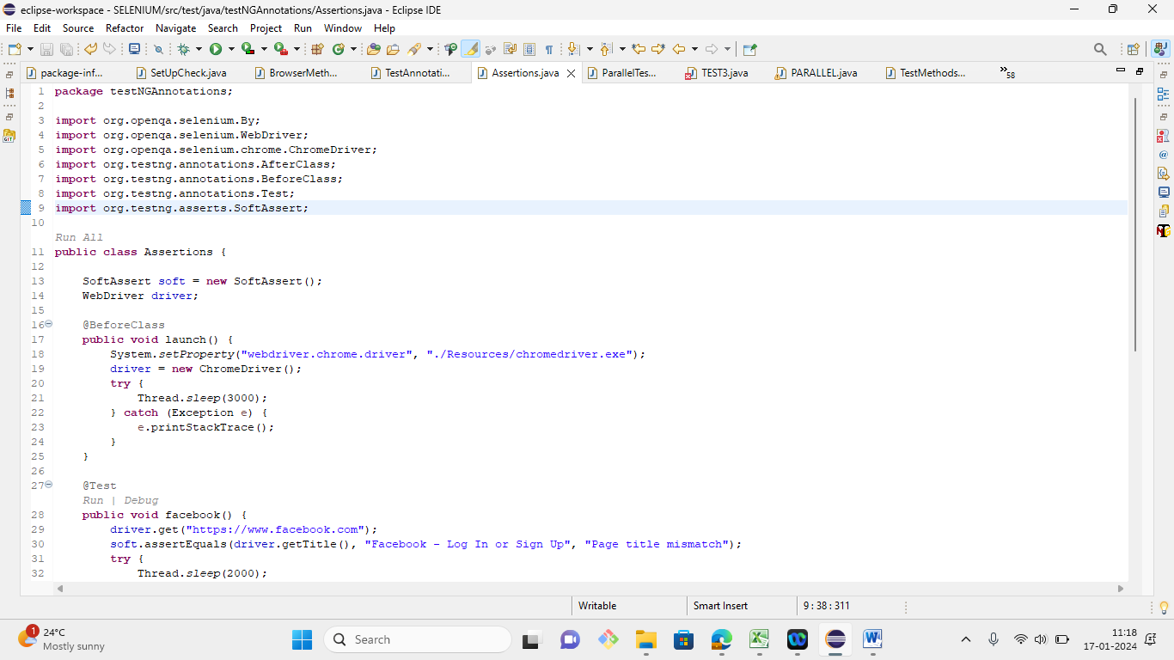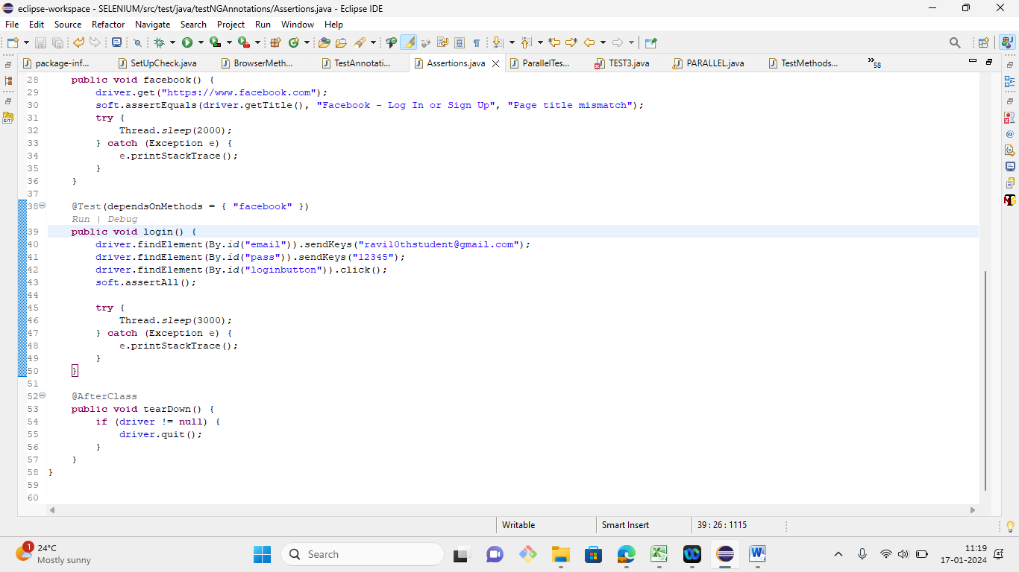

4. Demonstrate how extent reports are generated.

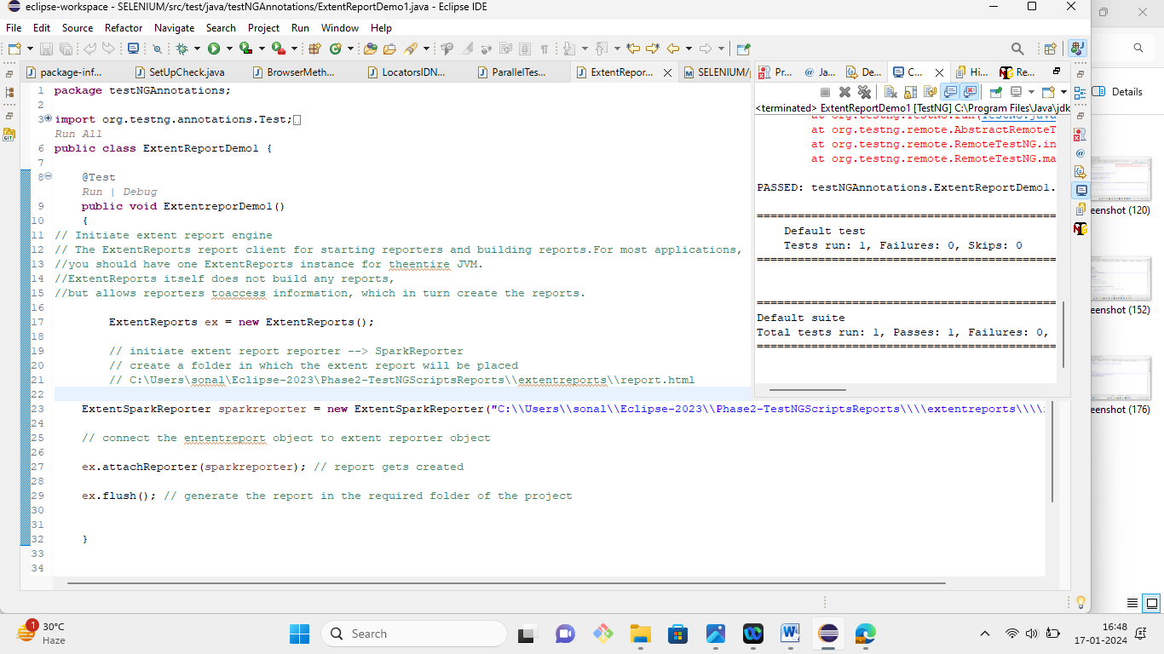

5. Demonstrate how test reports are exported to Excel.

